Black River Collection

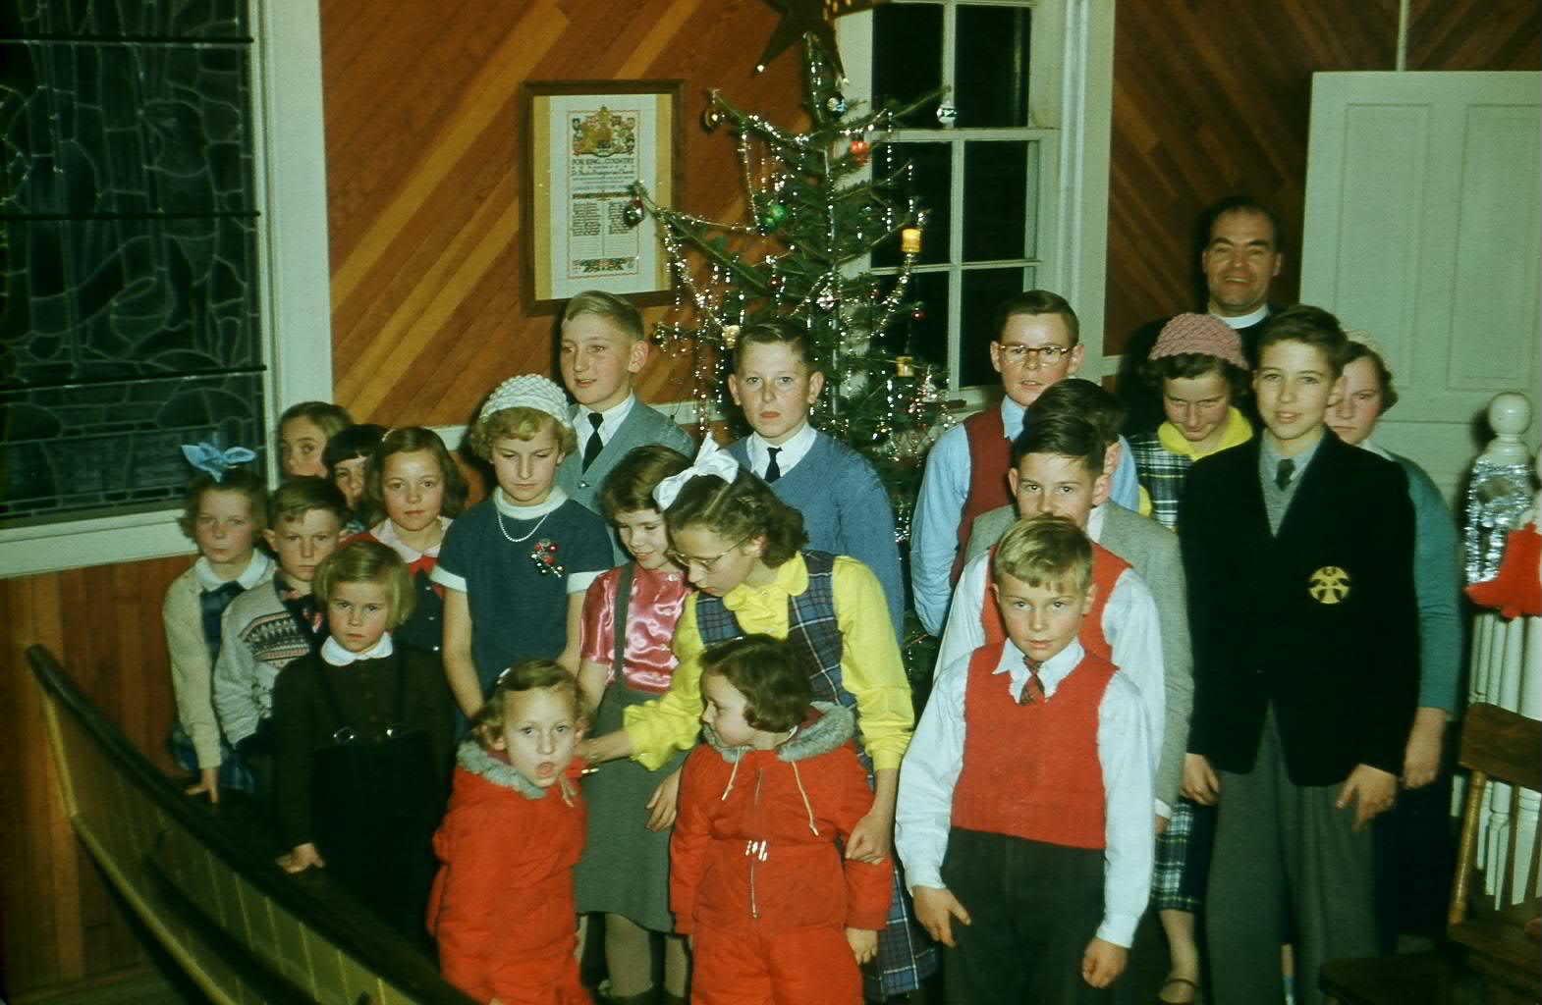
St. Paul’s Presbyterian Church

Notes: Young people at St. Paul’s Presbyterian Church following Christmas service in mid-1950’s.

Back row: Rev. Henry Russell, Minister
Fourth row: Lee Burnham, Unknown, Alexander Newton, Margaret glendenning, Sandra Taylor
Third Row: Unknown, Unknown, Unknown, Unknown, Brian Russell
Second row: Betty Ann glendenning, Unknown, Unknown, Donna, Unknown, Jeannie Glendenning, Newton
Front Row: Unknown. Eileen and Judy Glendenning, Unknown

Courtesy Don Glendenning

